**Press Release:** for immediate release

**Copernicus Masters 2018 Submissions Open 1 April**

**Copernicus Programme Provides Valuable Economic Benefits**

**Copernicus is Europe’s most ambitious Earth observation programme and provides full free and open access to data for the development of applications in a wide variety of domains. It is estimated that investments in the programme will increase to EUR 7.5 billion by 2020, while the economic benefit is expected to double in value. Every euro invested in Copernicus activities by public authorities, results in a EUR 1.4 benefit to the whole economy.**

**The Copernicus Masters awards applications and ideas that are using Copernicus data to tackle important challenges faced by business and society, with 2018 submissions opening 1 April.**

Oberpfaffenhofen, 28 April 2018 – 10 Petabytes of free Earth Observation (EO) data is generated by the Copernicus Programme every year. This data enables the Copernicus services to deliver near-real-time data on a global level, contributing toward the sustainable management of the environment. The data is sourced both from the family of Sentinel satellite missions, contributing missions (existing commercial and public satellites) and from a multitude of in situ sensors. Big data from space holds great potential for the development of ideas and solutions in many (non-space) sectors. As these ideas continue to develop into commercially viable solutions, the economic benefits continue to grow.

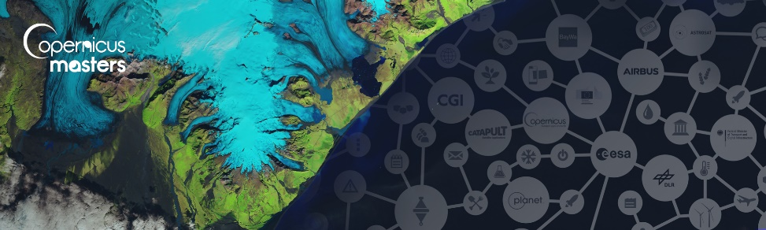The Copernicus Masters 2018 – Europe’s leading innovation competition for Earth observation (EO) – is searching for such outstanding ideas, applications, and business concepts from future-oriented SMEs, startups, universities and individuals in the fields of business, research, and higher education.

From 1 April to 30 June, participants of the Copernicus Masters can submit their innovative EO ideas to 16 challenges offered by the largest number of world-class partners since the competition started. Partners of the 2018 edition are the European Space Agency (ESA), the German Aerospace Center (DLR), CGI, Planet Inc., BayWa AG, Stevenson Astrosat Ltd., Airbus, Satellite Applications Catapult Ltd., and the German Federal Ministry of Transport and Digital Infrastructure (BMVI).

"The Copernicus Masters has developed into an important innovation driver for Earth observation. Solutions submitted to the competition not only benefit citizens but also bring multiple socio-economic advantages into various economic areas," states Josef Aschbacher, Director of ESA’s Earth Observation Programmes. ESA is an initiating partner of the Copernicus Masters and has set a challenge for participants every year since 2011.

Participants can demonstrate their innovative use of Earth observation data across a wide variety of challenge topics, including the fields of the Internet of Things (IoT), Artificial Intelligence (AI), machine learning, energy, health, sustainable living, smart farming, disaster management, maritime, defence & security, forestry, and smart farming, digital transportation, as well as smart cities.

For the second year running, the European Commission (EC) offers six additional European challenges, covering the topics of sustainable development, government, data access, B2B applications, land monitoring and emergency management. Participants also have the unique opportunity to build their solutions with additional satellite data sources offered by the new partners of the competition.

Together with cash prizes, challenge winners will receive access to an international network of leading Earth observation organisations, substantial satellite data quotas, crowd investing platform, and business development support worth more than EUR 600,000 in total. Additionally, the Overall Winner receives a VIP trip to a Satellite launch in Kourou valued at EUR 10,000.

“We're proud of the active role the Copernicus Masters is playing in the commercialisation of Earth observation services," adds Thorsten Rudolph, Managing Director of AZO, the competition organiser. "Since 2011, the competition has selected 87 winners in total. They were chosen out of more than 2700 entrants from 73 different countries, who submitted over 1100 cutting-edge business ideas. This is an excellent demonstration of how the innovation competition functions as a European deal flow pipeline for Earth observation."

In addition, the Copernicus Masters is complemented by the Copernicus Accelerator to empower the transformation of great ideas into commercially viable solutions through a tailored 12-month business coaching service. All winners of the Copernicus Masters 2018 will gain access to the Copernicus Accelerator if eligible.

For more details on this year's challenges, prizes, and partners, please visit [www.copernicus-masters.com](http://www.copernicus-masters.com). For more information, please see [space-of-innovation.com](http://www.space-of-innovation.com/).

Additional information on the Copernicus programme is available at: [www.esa.int/copernicus](http://www.esa.int/copernicus) and [www.copernicus.eu](http://www.copernicus.eu).

**About AZO – Your Partner in Competition & Innovation**

AZO Anwendungszentrum GmbH Oberpfaffenhofen is an international networking and branding company initiating the most important space-related innovation competitions with more than 15,000 participants, over 200 industrial & public - and 400 international stakeholders. The Masters Series, presented by AZO consists of [European Satellite Masters](http://www.esnc.eu) (ESNC), [Copernicus Masters](http://www.copernicus-masters.com/), [Space Exploration Masters](http://www.space-exploration-masters.com/), and [INNOspace Masters](http://www.innospace-masters.de/?lang=en). AZO has been supporting entrepreneurship with more than 130 company foundations to date and the creation of 1,800 high-tech jobs in Bavaria with an annual turnover of about EUR 150 million. Additionally, AZO runs a very successful business angel network which invested more than EUR 130 million Venture Capital in 2016/17 as well as the ESA Incubation Centre (ESA BIC) Bavaria. For more information, please visit [www.azo-space.com](http://www.azo-space.com).

**Copernicus Accelerator - A PROJECT OF THE EUROPEAN COMMISSION – DG GROWTH**

The Copernicus Accelerator Programme is an initiative funded by the Directorate-General for Internal Market, Industry, Entrepreneurship and SMEs (DG GROWTH) of the European Commission. The DG GROWTH is responsible for: Completing the Internal Market for goods and services, helping turn the EU into a smart, sustainable, and inclusive economy by implementing the industrial and sectorial policies of the flagship Europe 2020 initiative, fostering entrepreneurship and growth by reducing the administrative burden on small businesses, facilitating access to funding for small and medium-sized enterprises (SMEs), and supporting access to global markets for EU companies. All of these actions are encapsulated in the Small Business Act, generating policy on the protection and enforcement of industrial property rights, coordinating the EU’s position and negotiations in the international intellectual property rights (IPR) system, and assisting innovators on using IP rights effectively; and implementing the EU’s space policy via its two large-scale satellite programmes Copernicus (for Earth observation) and Galileo (for global navigation), as well as research actions designed to spur technological innovation and economic growth. <http://ec.europa.eu/growth/about-us/index_en.html>

|  |  |
| --- | --- |
| **Press contact:** | AZO |
| Regine Heue | Anwendungszentrum GmbH Oberpfaffenhofen |
| Head of Marketing & Communications | Friedrichshafener Str. 1 |
| marketing@azo-space.com | 82205 Gilching/Oberpfaffenhofen |